
Hea
Dates for the Diary

October
Fri 3rd Georgian/Victorian dress up day
Fri 17th PTA Disco
Tues 21st Parent’s Evening
Wed 22nd School photographer in
Wed 22nd Parent’s Evening
Thurs 23rd Parent’s Evening
Fri 24th Community Worship Enrichment afternoon
Fri 24th Term Ends

November
Mon 3rd School open

Earrings
Children are allowed to wear stud earrings only in school. Please be mindful that your child needs to be able to take them out before PE and other sporting activities. Children should not tape up their earrings to play sports.

Value Stars
Congratulations to the following children who have received Value Stars:
R – Olivia
1 – Adeline
2 – Grace
3 – Ari
4 – Charles
5 – Issac
6 - Eloise

6 - Jaiden

Year 3 and 4 Roman Wow Day

We learnt to count in Roman numerals, made up our own amazing mythical creatures and made our own Laurel wreath crowns as well as learning about the Roman invasion of Britain. The children all participated and enjoyed the day!

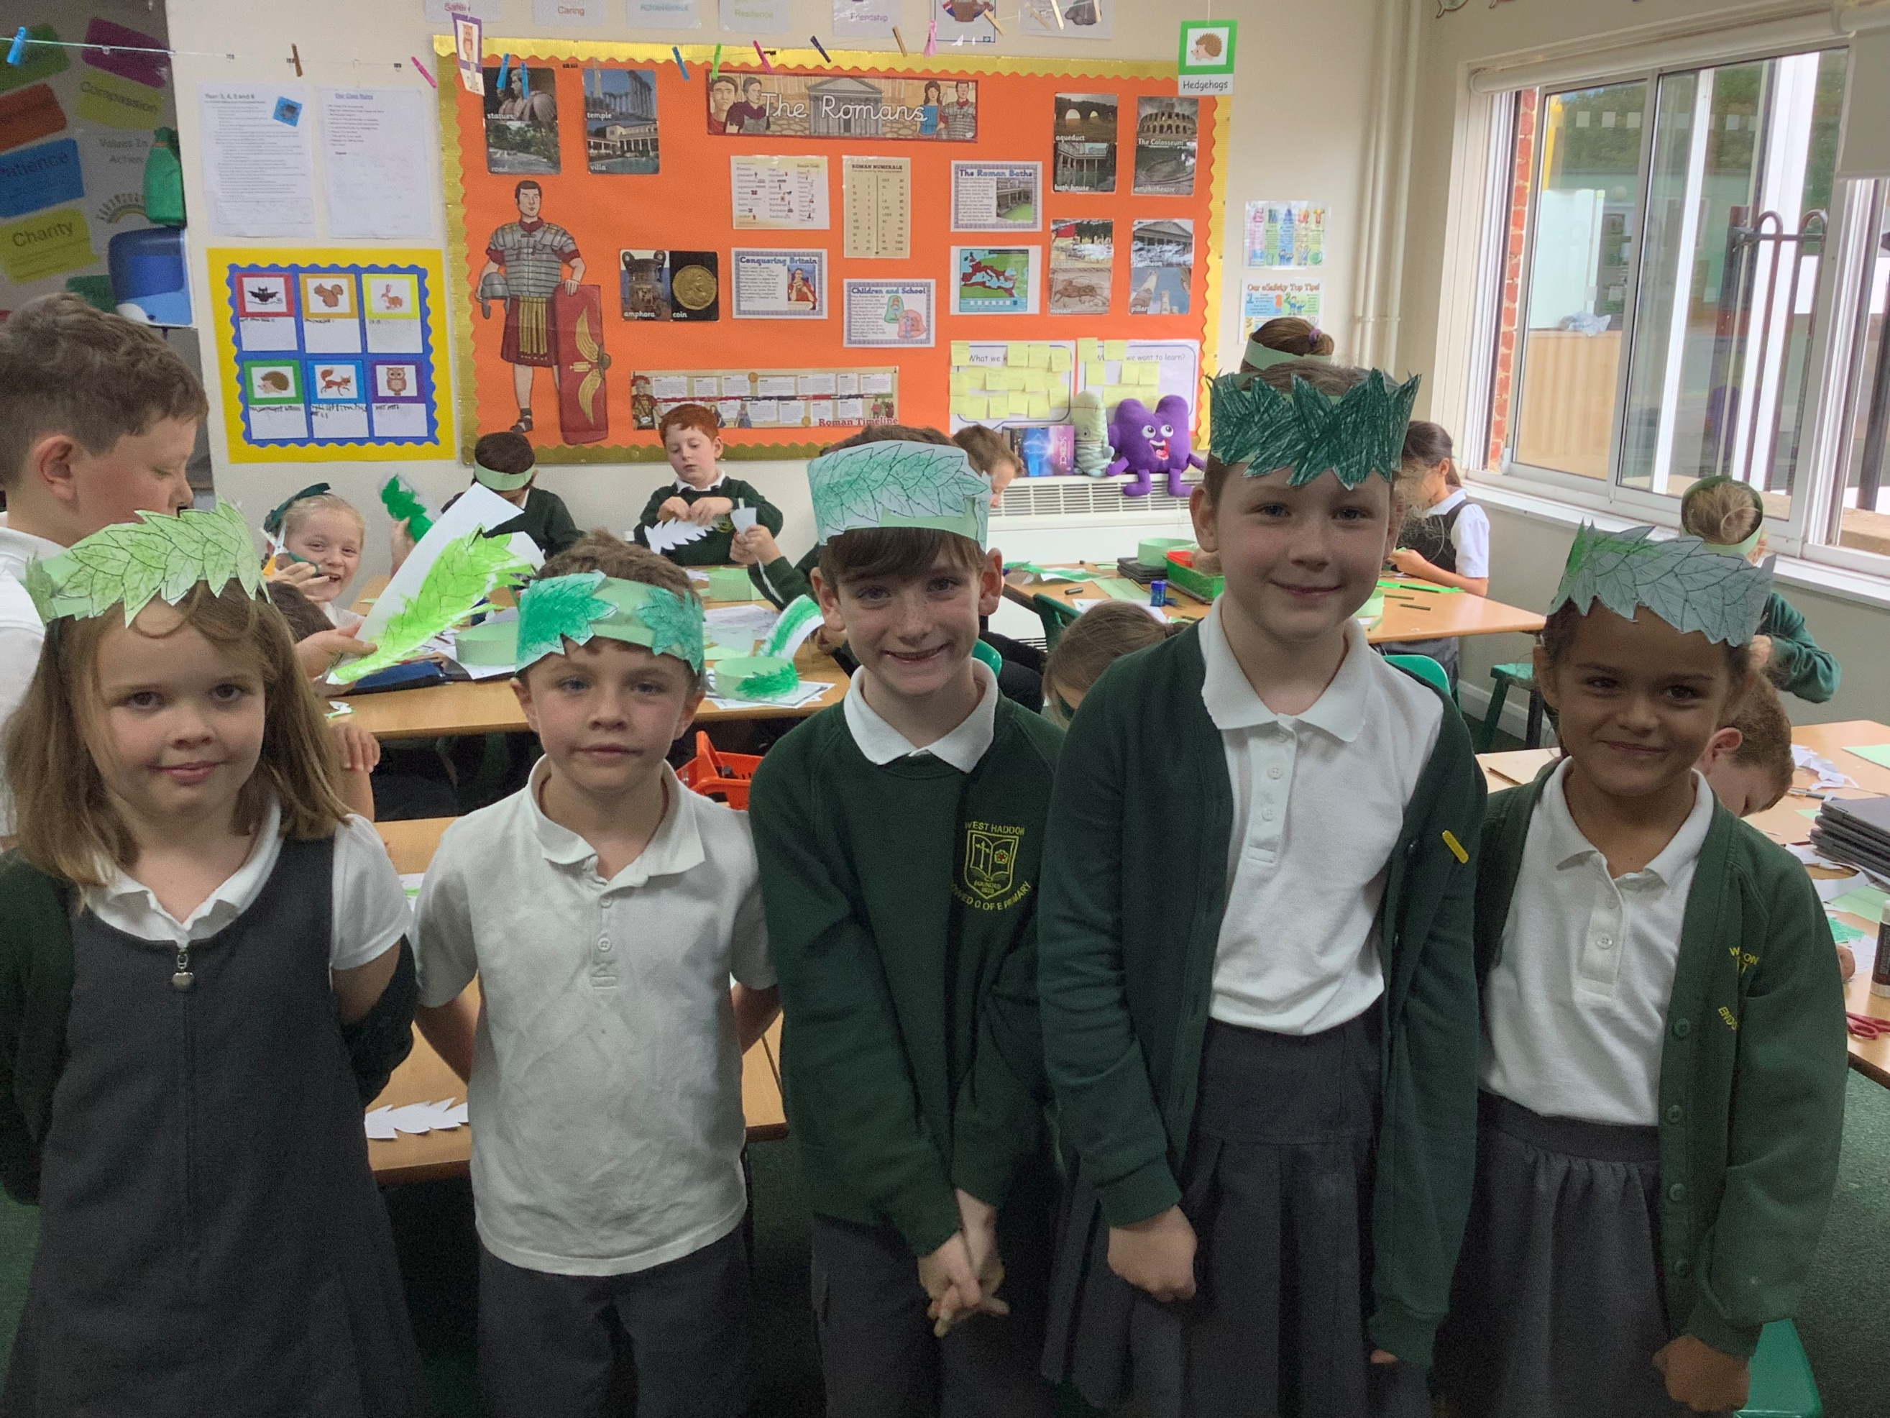
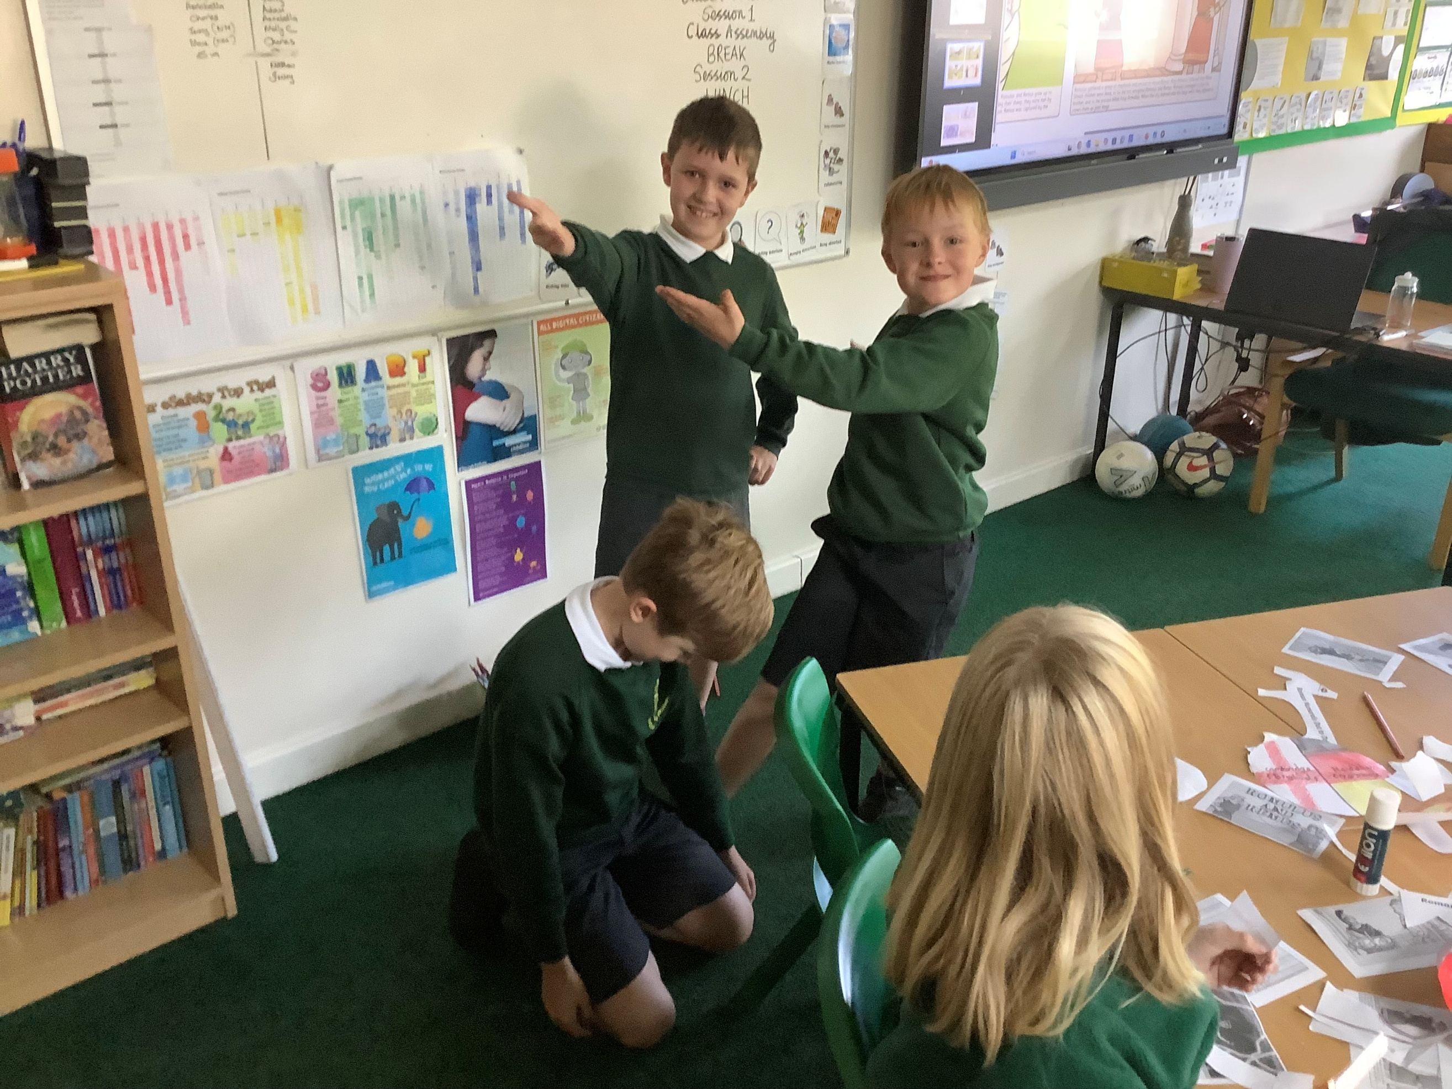

SECONDARY SCHOOL APPLICATIONS
Parents/carers of pupils in Year 6 who are due to transfer to secondary school in September 2026 are reminded that the closing date for applications is 5pm on 31st October 2025. If you have not already done so, please ensure that you apply for a secondary school place for your child and that this is received before the closing date. A late application will mean that the chance of getting one of your preferred schools is reduced.
School places are not automatically allocated to any child even if there is an older brother or sister attending a secondary school or you live in an area linked to a particular school.

Our value for the month is
Friendship

WEST HADDON PRIMARY SCHOOL
Please remember to visit our school website regularly for useful information http://www.westhaddonprimary.net
Follow us on Twitter: @ bursarwest Facebook: West Haddon Primary School

Newsletter No. 4
26th September 2025

